IMPORTANT – before you start doing your solution, MUST do the following steps:

- Create your MS SQL database named StudentGradeDB by running code in script
StudentGradeDB.sql.
- Create a folder named jdbc (1) under your project, copy given file sqljdbc42.jar to (1)
- Copy given file DBContext.java (2) to source package (src\java) folder under your netbeans project. You might need to use and name a java package for (2), free to set the name of package.
- You MUST use DBContext.java for your all database connection.

Question 2: (4.0 Point)
Design the form, which at running might look something like figure below: (0.5 Point)
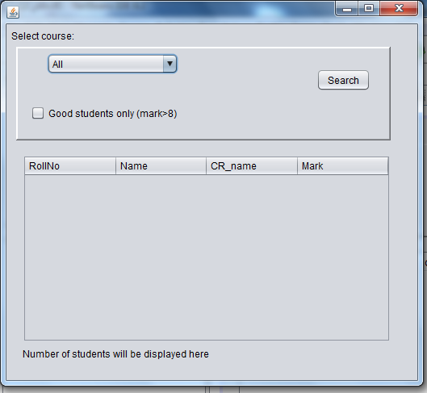
By default the select course combo box value is All and the “Good students only (mark>8) is unchecked. If you click the search button, the screen appear like below:
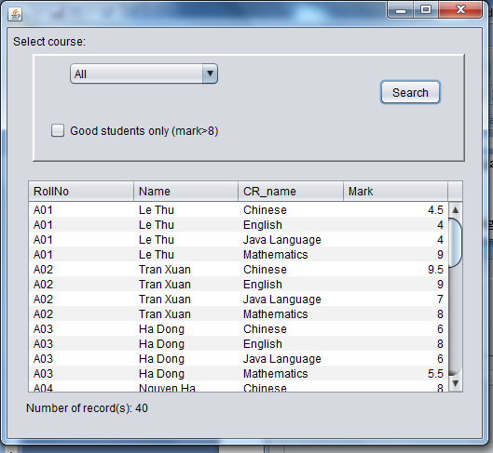
If you select the course, e.g. CHIN, the GUI looks like:
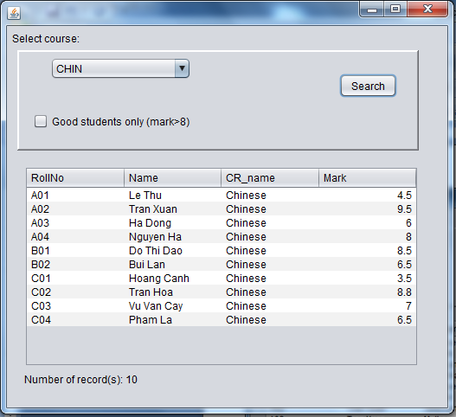
If the check box is checked, then the GUI looks like:
